Japan, August 3-7
I was invited to be the Jewish international representative at the special international conference celebrating the 30th anniversary of the most important interreligious event in the modern history of Japan, the Mount Hiei summit of prayer for peace. These gatherings organized by the Japanese Interreligious Council are hosted by the Japanese Tendai Buddhist Order. The summit involved the major leaders of religions in Japan as well as religious leaders from around the world. These include Cardinal John Tong Hon of Hong Kong representing Pope Francis, Dr. Mohammad El Issa, Secretary General of the World Muslim League, and Dr. Ela Ghandi (grandaughter of the Mahatma.)

Accompanying me at the summit in Kyoto and the ceremony on Mount Hiei was an AJC delegation. We went on to Tokyo where we met with Japanese religious leaders, at the Meiji shrine, the HQ of the Buddhist organization Rissho Kosei Kai and the Catholic Primate. In addition we were hosted by the Jewish community of Tokyo, were briefed by Israel’s Ambassador Ruth Kahanoff, and were hosted at the Diet by Senator Hiroe Makiyama.

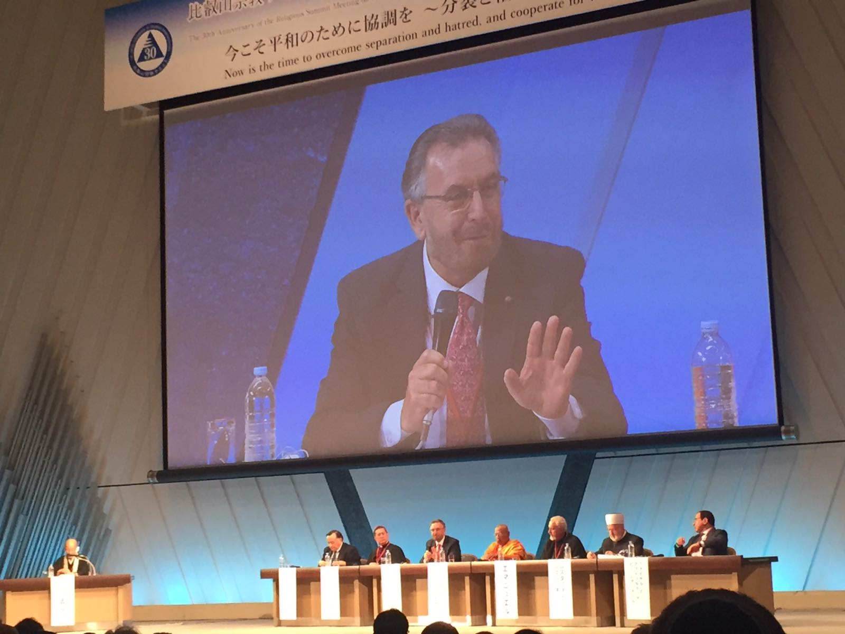
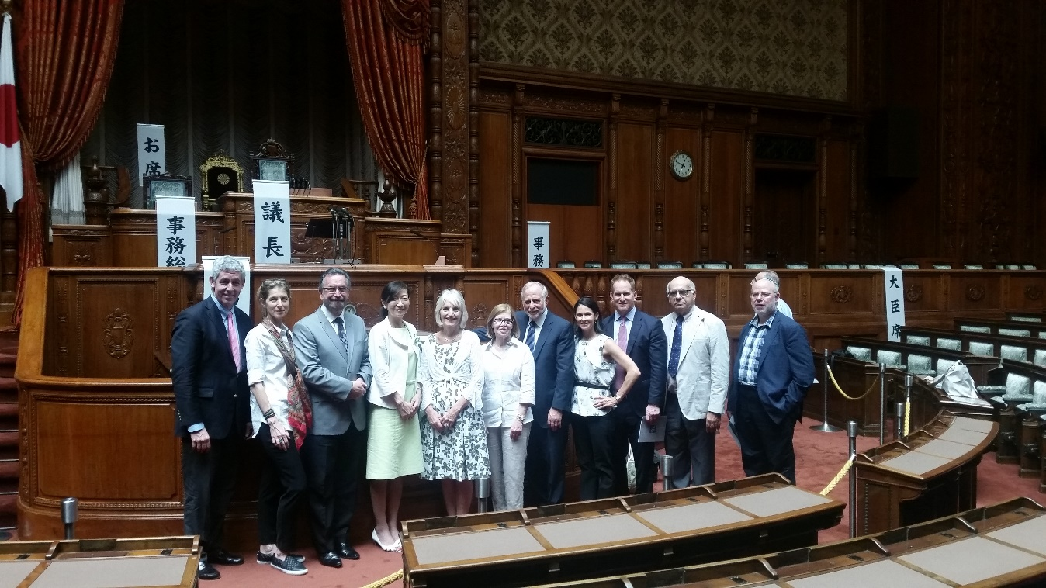

Alpbach, Austria , August 21/22.
The Ethics in Action Council founded at the initiative of Pope Francis and convened by the Pontifical Academy of Sciences and Social Sciences together with Religions for Peace , was invited to hold its August meeting at the European Forum in Alpbach. The Ethics in Action Council (of which I am a part) brings religious leaders together with leading personalities from the academic and business worlds to draw on the wisdom of the different traditions in promoting the UN Sustainable Development Goals . This meeting focused on the subject of Corporate Ethical Social Responsibility.
In addition, religious figures on the Council including myself participated in a panel and session at the Alpbach Forum on Religions and the Environment.
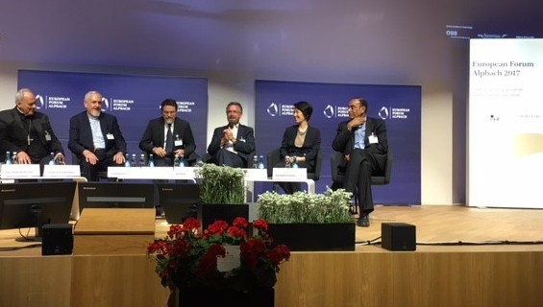
Rimini, Italy, August 24th
The annual meeting at Rimini organized by the Catholic organization Communione e Liberazione, brings some three quarters of a million to a religiously inspired intellectual and cultural festival .
I was invited to join Dr. Mohammed Sammak of Lebanon and Archbishop Silvano Tomasi the Vatican’s past representative to the UN institutions to be part of a panel on interfaith relations that was attended by some ten thousand people.

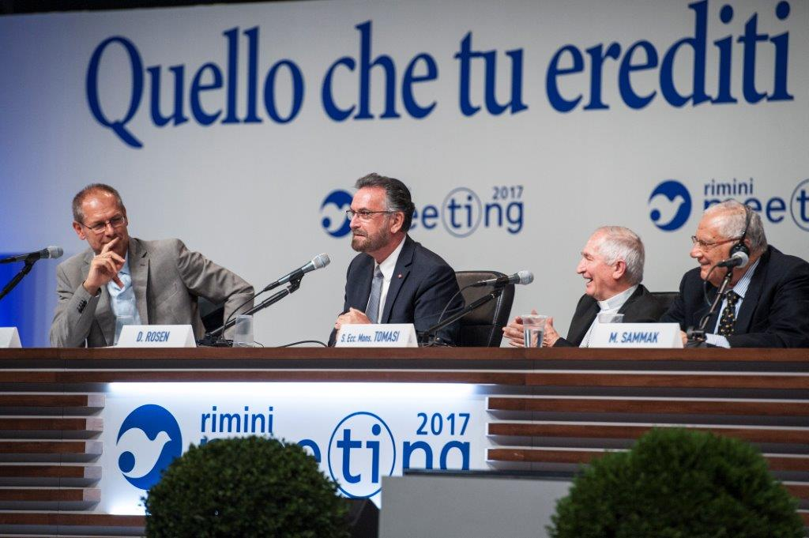

Vatican, August 31st
A document formulated by the Conference of European Rabbis , the Rabbinical Council of America, and the Chief Rabbinate of Israel, expressing appreciation to the Catholic Church for its dramatic transformation in its teaching on Jews, Judaism and Israel, and expressing commitment to an ethical partnership for the benefit of all humanity, was presented to Pope Francis at a private audience at the Vatican of which I was part, as one of the formulators of the text and as honorary Advisor on interfaith relations to the Chief Rabbinate of Israel.
See: http://www.lastampa.it/2017/09/02/vaticaninsider/eng/documents/orthodox-judaism-and-the-catholic-church-celebrating-a-new-milestone-in-catholicjewish-relations-7CJjFWmFvkmLveLa9V6bQI/pagina.html
https://www.ncronline.org/news/vatican/pope-offers-early-new-year-greetings-worlds-jewish-communities
en.radiovaticana.va: http://en.radiovaticana.va/news/1333820
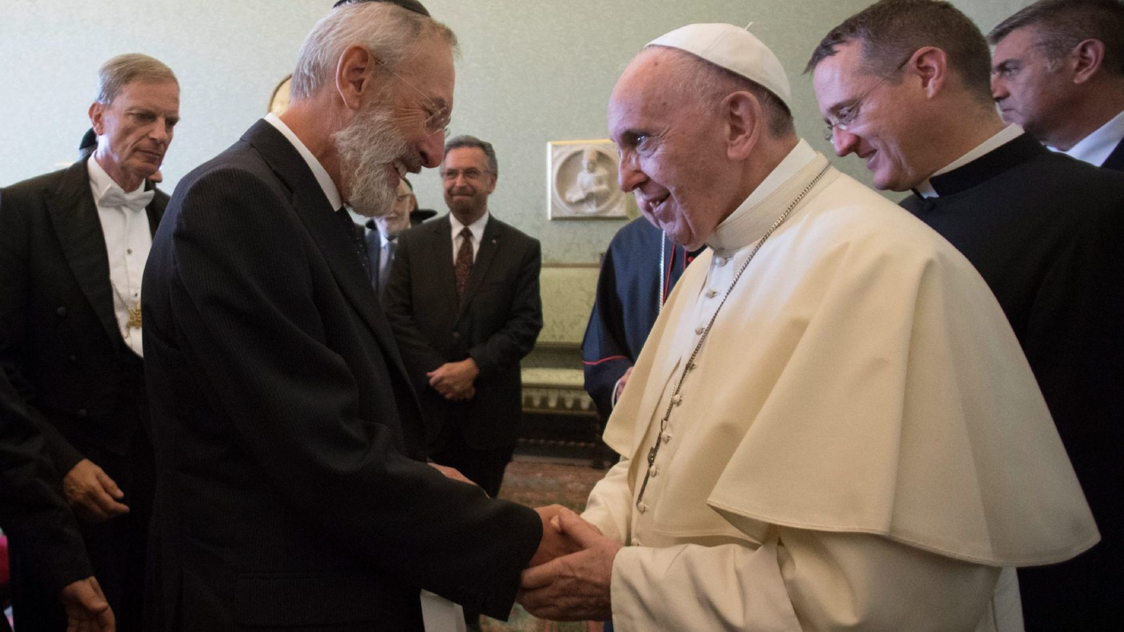
Munster/Osnabruck, Germany,September 10-12
The annual multi-faith gathering of the Catholic Community of Sant Egidio perpetuating the “spirit of Assisi” of Pope John Paul II’s historic multi-faith gathering was held this year in Munster and Osnabruck, the cities where the treaty of Westphalia was negotiated and signed. I addressed a panel at the conference on the subject of The Economy and Social Justice.
